Elasticity of Demand fro gasoline Project 1

Bridget Antwiwaa

2022-03-11

importing my data

data1= read.csv(choose.files(), header = T)

calling my data

GC = data1$Gasoline.Consumption  
PG = data1$Price.of.Gas  
rDPI = data1$Disposable.Personal.Income  
Pop= data1$population  
PCE=data1$Consumption.Expenditures  
Infla= data1$Inflation  
one.T= data1$One.year.treasury  
ten.T= data1$ten.year.treasury  
UR = data1$Unemployment.rate  
Year = data1$Year  
month = data1$Month  
date = data1$Date

per capital gasoline consuption variable (PCGC)

data1$PCGC= (GC*42)/(Pop)

real retail price of gasoline (rPG)

data2=subset(data1, Year == "2000")  
a=mean(data2[,8])  
PCE.deflator = PCE/a  
data1$rPG = PG/PCE.deflator

real per capital disposable income(rCPI)

d2=subset(data1, Year == "2012")  
b=mean(d2[,8])  
PCE12.deflator = PCE/b  
data1$rCPI = (PCE12.deflator/PCE.deflator) *rDPI

create the 12 dummy variables

data1$Jan = ifelse(month==1,1,0)  
data1$Feb =ifelse(month==2,1,0)  
data1$Mar= ifelse(month==3,1,0)  
data1$Apr= ifelse(month==4,1,0)  
data1$May= ifelse(month==5,1,0)  
data1$Jun= ifelse(month==6,1,0)  
data1$Jul= ifelse(month==7,1,0)  
data1$Aug= ifelse(month==8,1,0)  
data1$Sep= ifelse(month==9,1,0)  
data1$Oct= ifelse(month==10,1,0)  
data1$Nov= ifelse(month==11,1,0)  
data1$Dec= ifelse(month==12,1,0)

Descriptive statistics for all variables

vars = data1[,c("PCGC", "rPG","rCPI","Unemployment.rate", "One.year.treasury",   
 "ten.year.treasury", "Inflation")]  
stargazer::stargazer(vars, type = "text")

##   
## ================================================================  
## Statistic N Mean St. Dev. Min Max   
## ----------------------------------------------------------------  
## PCGC 563 37.515 2.673 22.413 45.977   
## rPG 563 1.774 0.502 0.988 3.346   
## rCPI 563 25,030.130 6,237.732 15,166.740 45,098.830  
## Unemployment.rate 563 6.314 1.715 3.500 14.700   
## One.year.treasury 563 6.060 3.299 0.620 15.320   
## ten.year.treasury 563 4.832 3.796 0.050 16.720   
## Inflation 563 3.229 2.420 -1.500 11.600   
## ----------------------------------------------------------------

Descriptive statistics of 3 specific time periods

date = as.Date(date)  
Time.d1 = subset(data1, date>="1975-11-01" & date<="1980-11-01")  
Time.d2 = subset(data1, date>="2001-03-01" & date<="2006-03-01")  
Time.d3 = subset(data1, date>="2016-11-01" & date<="2021-11-01")  
stargazer::stargazer(Time.d1, type = "text")

##   
## ==========================================================================  
## Statistic N Mean St. Dev. Min Max   
## --------------------------------------------------------------------------  
## Year 60 1,977.833 1.475 1,975 1,980   
## Month 60 6.500 3.481 1 12   
## Gasoline.Consumption 60 214,402.500 13,287.150 181,641 244,041   
## Price.of.Gas 60 0.796 0.235 0.586 1.271   
## Disposable.Personal.Income 60 21,116.200 580.397 20,012 21,908   
## population 60 222,372.400 3,478.709 216,851 228,515   
## Consumption.Expenditures 60 34.426 3.922 29.132 42.351   
## Inflation 60 7.585 1.887 5.100 11.600   
## One.year.treasury 60 8.711 1.426 6.870 12.750   
## ten.year.treasury 60 8.338 2.581 4.890 15.820   
## Unemployment.rate 60 6.798 0.810 5.600 8.300   
## PCGC 60 40.509 2.658 35.105 45.977   
## rPG 60 1.774 0.315 1.507 2.443   
## rCPI 60 16,489.750 453.235 15,627.470 17,108.070  
## Jan 60 0.083 0.279 0 1   
## Feb 60 0.083 0.279 0 1   
## Mar 60 0.083 0.279 0 1   
## Apr 60 0.083 0.279 0 1   
## May 60 0.083 0.279 0 1   
## Jun 60 0.083 0.279 0 1   
## Jul 60 0.083 0.279 0 1   
## Aug 60 0.083 0.279 0 1   
## Sep 60 0.083 0.279 0 1   
## Oct 60 0.083 0.279 0 1   
## Nov 60 0.083 0.279 0 1   
## Dec 60 0.083 0.279 0 1   
## --------------------------------------------------------------------------

stargazer::stargazer(Time.d2, type = "text")

##   
## ==========================================================================  
## Statistic N Mean St. Dev. Min Max   
## --------------------------------------------------------------------------  
## Year 60 2,003.167 1.475 2,001 2,006   
## Month 60 6.500 3.481 1 12   
## Gasoline.Consumption 60 272,516.500 12,645.630 238,713 295,651   
## Price.of.Gas 60 1.745 0.397 1.130 2.927   
## Disposable.Personal.Income 60 35,593.630 954.311 33,954 37,591   
## population 60 291,064.500 3,915.130 284,380 297,734   
## Consumption.Expenditures 60 83.117 2.786 79.395 88.417   
## Inflation 60 2.172 0.692 0.700 3.800   
## One.year.treasury 60 4.420 0.459 3.330 5.390   
## ten.year.treasury 60 2.440 1.072 1.010 4.680   
## Unemployment.rate 60 5.447 0.495 4.300 6.300   
## PCGC 60 39.322 1.704 34.619 42.113   
## rPG 60 1.630 0.318 1.104 2.598   
## rCPI 60 27,795.250 745.226 26,514.850 29,355.000  
## Jan 60 0.083 0.279 0 1   
## Feb 60 0.083 0.279 0 1   
## Mar 60 0.083 0.279 0 1   
## Apr 60 0.083 0.279 0 1   
## May 60 0.083 0.279 0 1   
## Jun 60 0.083 0.279 0 1   
## Jul 60 0.083 0.279 0 1   
## Aug 60 0.083 0.279 0 1   
## Sep 60 0.083 0.279 0 1   
## Oct 60 0.083 0.279 0 1   
## Nov 60 0.083 0.279 0 1   
## Dec 60 0.083 0.279 0 1   
## --------------------------------------------------------------------------

stargazer::stargazer(Time.d3, type = "text")

##   
## ==========================================================================  
## Statistic N Mean St. Dev. Min Max   
## --------------------------------------------------------------------------  
## Year 60 2,018.833 1.475 2,016 2,021   
## Month 60 6.500 3.481 1 12   
## Gasoline.Consumption 60 273,017.900 23,478.900 175,973 304,844   
## Price.of.Gas 60 2.560 0.340 1.876 3.385   
## Disposable.Personal.Income 60 45,415.680 2,715.579 42,147 57,752   
## population 60 328,189.200 2,307.159 324,052 331,716   
## Consumption.Expenditures 60 109.760 3.115 104.826 117.450   
## Inflation 60 1.967 0.936 0.400 5.100   
## One.year.treasury 60 1.971 0.755 0.620 3.150   
## ten.year.treasury 60 1.233 0.934 0.050 2.700   
## Unemployment.rate 60 5.097 2.281 3.500 14.700   
## PCGC 60 34.950 3.105 22.413 39.010   
## rPG 60 1.819 0.219 1.329 2.251   
## rCPI 60 35,465.330 2,120.609 32,912.800 45,098.830  
## Jan 60 0.083 0.279 0 1   
## Feb 60 0.083 0.279 0 1   
## Mar 60 0.083 0.279 0 1   
## Apr 60 0.083 0.279 0 1   
## May 60 0.083 0.279 0 1   
## Jun 60 0.083 0.279 0 1   
## Jul 60 0.083 0.279 0 1   
## Aug 60 0.083 0.279 0 1   
## Sep 60 0.083 0.279 0 1   
## Oct 60 0.083 0.279 0 1   
## Nov 60 0.083 0.279 0 1   
## Dec 60 0.083 0.279 0 1   
## --------------------------------------------------------------------------

## Discuss about the descriptive statistics

Time series graph of the main variables

PCGC graph

library(ggplot2)  
ggplot()+  
 geom_line(data = data1, mapping = aes(x=date,y=PCGC), col = "red")+xlab("Year")+ylab("Montly Gasoline")+labs(title = "Figure 1. Monthly Per Capita Gasoline Consumption for 1975 to 2021")

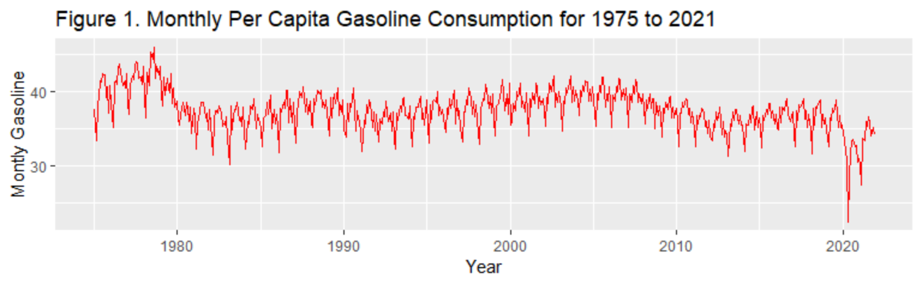

rPG graph

ggplot()+  
 geom_line(data = data1, mapping = aes(x=date,y=rPG), col = "blue")+xlab("Year")+ylab("Real Price")+labs(title = "Figure 2. Real Retail Price for January 1975 to November 2021")

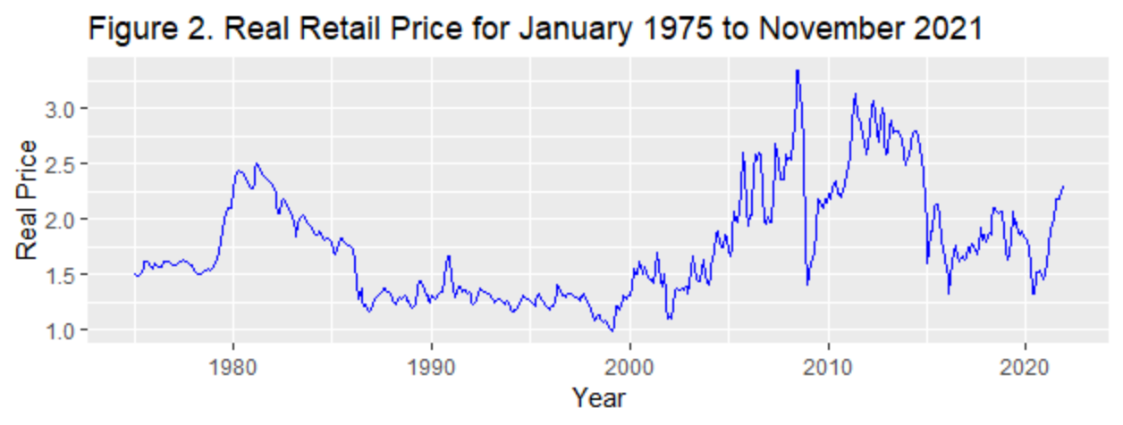

rCPI graph

ggplot()+  
 geom_line(data = data1, mapping = aes(x=date,y=rCPI), col = "pink")+xlab("Year")+ylab(" Real Per Capita Disposable Income")+labs(title = "Figure 3. Monthly Real Per Capita Disposable Income for 1975 to 2021")

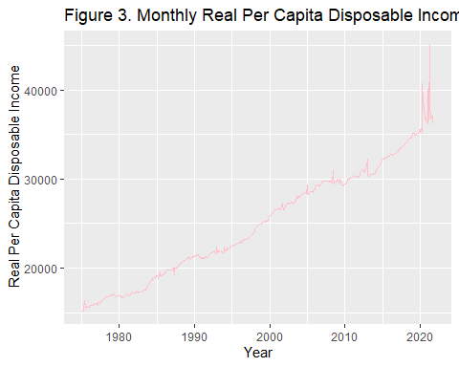

Time series graph of the main variables for all the time period

Time.d1$obsn = 1:nrow(Time.d1)  
Time.d2$obsn = 1:nrow(Time.d2)  
Time.d3$obsn = 1:nrow(Time.d3)  
  
windows(width = 12, height = 10)  
ggplot(NULL, aes(obsn, rPG))+  
 geom_line(data =Time.d1, aes(col = "green"))+  
 geom_line(data =Time.d2, aes(col = "purple"))+  
 geom_line(data =Time.d3, aes(col = "gold"))+  
 scale_color_identity(name = "Subperiods", breaks = c("green", "purple", "gold"), labels =c("Nov75-Nov80", "Mar01-Mar06", "Feb15-Feb20"), guide = "legend")

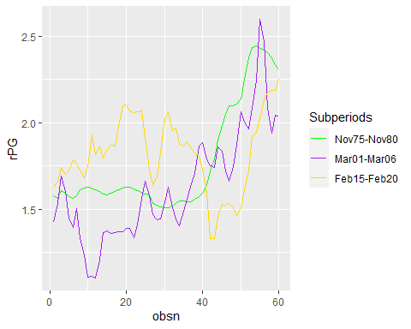

D. Estimates of Table 1 Models

reg1=lm(log(PCGC)~log(rPG)+log(rCPI)+Jan+Feb+Mar+Apr+May+Jun+Jul+Aug +Sep+Oct+Nov,data = Time.d1)  
reg2=lm(log(PCGC)~log(rPG)+log(rCPI)+Jan+Feb+Mar+Apr+May+Jun+Jul+Aug +Sep+Oct+Nov,data = Time.d2)  
stargazer::stargazer(reg1,reg2, type = "text")

##   
## ==========================================================  
## Dependent variable:   
## ----------------------------  
## log(PCGC)   
## (1) (2)   
## ----------------------------------------------------------  
## log(rPG) -0.309*** -0.042***   
## (0.023) (0.013)   
##   
## log(rCPI) 0.524*** 0.554***   
## (0.136) (0.091)   
##   
## Jan -0.080*** -0.044***   
## (0.016) (0.007)   
##   
## Feb -0.130*** -0.120***   
## (0.016) (0.007)   
##   
## Mar -0.019 -0.007   
## (0.016) (0.007)   
##   
## Apr -0.023 -0.025***   
## (0.016) (0.007)   
##   
## May 0.012 0.025***   
## (0.016) (0.007)   
##   
## Jun 0.019 -0.001   
## (0.016) (0.007)   
##   
## Jul 0.028* 0.040***   
## (0.016) (0.007)   
##   
## Aug 0.040** 0.043***   
## (0.016) (0.007)   
##   
## Sep -0.029* -0.039***   
## (0.016) (0.007)   
##   
## Oct 0.0004 0.006   
## (0.016) (0.007)   
##   
## Nov -0.048*** -0.033***   
## (0.016) (0.007)   
##   
## Constant -1.200 -1.965**   
## (1.312) (0.925)   
##   
## ----------------------------------------------------------  
## Observations 60 60   
## R2 0.881 0.955   
## Adjusted R2 0.847 0.942   
## Residual Std. Error (df = 46) 0.026 0.011   
## F Statistic (df = 13; 46) 26.143*** 74.913***   
## ==========================================================  
## Note: *p<0.1; **p<0.05; ***p<0.01

Questions to answer section (D1 to D5):

E. Estimate Table 2 model for linear Model

linear.reg1=lm(PCGC~rPG+rCPI,data = Time.d1)  
linear.reg2=lm(PCGC~rPG+rCPI,data = Time.d2)  
stargazer::stargazer(linear.reg1,linear.reg2,type = "text")

##   
## ==========================================================  
## Dependent variable:   
## ----------------------------  
## PCGC   
## (1) (2)   
## ----------------------------------------------------------  
## rPG -5.809*** -0.178   
## (0.968) (1.045)   
##   
## rCPI 0.001* 0.0004   
## (0.001) (0.0004)   
##   
## Constant 29.209*** 27.986**   
## (10.464) (11.181)   
##   
## ----------------------------------------------------------  
## Observations 60 60   
## R2 0.391 0.026   
## Adjusted R2 0.369 -0.009   
## Residual Std. Error (df = 57) 2.111 1.711   
## F Statistic (df = 2; 57) 18.278*** 0.747   
## ==========================================================  
## Note: *p<0.1; **p<0.05; ***p<0.01

Questions to answer section:

F. Estimate Table 4:

Infla.reg1=lm(log(PCGC)~log(rPG)+log(rCPI)+log(Inflation)+log(One.year.treasury)+log(Unemployment.rate)+Jan+Feb+Mar+Apr+May+Jun+Jul+Aug+Sep  
 +Oct+Nov,data = Time.d1)  
stargazer::stargazer(Infla.reg1, type = "text")

##   
## ==================================================  
## Dependent variable:   
## ---------------------------  
## log(PCGC)   
## --------------------------------------------------  
## log(rPG) -0.200***   
## (0.065)   
##   
## log(rCPI) 0.420   
## (0.333)   
##   
## log(Inflation) -0.070   
## (0.050)   
##   
## log(One.year.treasury) -0.014   
## (0.063)   
##   
## log(Unemployment.rate) -0.094   
## (0.064)   
##   
## Jan -0.081***   
## (0.016)   
##   
## Feb -0.131***   
## (0.016)   
##   
## Mar -0.020   
## (0.016)   
##   
## Apr -0.024   
## (0.016)   
##   
## May 0.010   
## (0.016)   
##   
## Jun 0.015   
## (0.017)   
##   
## Jul 0.025   
## (0.016)   
##   
## Aug 0.037**   
## (0.016)   
##   
## Sep -0.032*   
## (0.016)   
##   
## Oct -0.001   
## (0.016)   
##   
## Nov -0.047***   
## (0.016)   
##   
## Constant 0.101   
## (3.272)   
##   
## --------------------------------------------------  
## Observations 60   
## R2 0.891   
## Adjusted R2 0.850   
## Residual Std. Error 0.026 (df = 43)   
## F Statistic 21.859*** (df = 16; 43)   
## ==================================================  
## Note: *p<0.1; **p<0.05; ***p<0.01

Question to answer:

G. Estimate Elasticities Using Recent Data

Covid.reg1=lm(log(PCGC)~log(rPG)+log(rCPI)+Jan+Feb+Mar+Apr+May+Jun+Jul+Aug+Sep+Oct+Nov,data = Time.d3)  
  
Covid.reg2=lm(log(PCGC)~log(rPG)+log(rCPI)+log(Inflation)+log(ten.year.treasury)+Jan+Feb+Mar+Apr+May+Jun+Jul+Aug+Sep+Aug+Nov,data = Time.d3)  
  
stargazer::stargazer(Covid.reg1,Covid.reg2, type = "text")

##   
## ======================================================================  
## Dependent variable:   
## -----------------------------------------------  
## log(PCGC)   
## (1) (2)   
## ----------------------------------------------------------------------  
## log(rPG) 0.367*** -0.196   
## (0.057) (0.123)   
##   
## log(rCPI) -0.856*** -0.198   
## (0.123) (0.159)   
##   
## log(Inflation) 0.160***   
## (0.034)   
##   
## log(ten.year.treasury) 0.045***   
## (0.008)   
##   
## Jan -0.033 -0.054**   
## (0.032) (0.022)   
##   
## Feb -0.117*** -0.128***   
## (0.032) (0.022)   
##   
## Mar 0.017 -0.0003   
## (0.032) (0.022)   
##   
## Apr -0.075** -0.053**   
## (0.032) (0.022)   
##   
## May -0.0004 0.036   
## (0.032) (0.023)   
##   
## Jun 0.004 0.030   
## (0.032) (0.022)   
##   
## Jul 0.031 0.054**   
## (0.033) (0.022)   
##   
## Aug 0.035 0.057**   
## (0.032) (0.022)   
##   
## Sep -0.044 -0.016   
## (0.033) (0.022)   
##   
## Oct -0.011   
## (0.032)   
##   
## Nov -0.035 -0.020   
## (0.032) (0.022)   
##   
## Constant 12.315*** 5.671***   
## (1.293) (1.642)   
##   
## ----------------------------------------------------------------------  
## Observations 60 60   
## R2 0.791 0.873   
## Adjusted R2 0.732 0.834   
## Residual Std. Error 0.050 (df = 46) 0.039 (df = 45)   
## F Statistic 13.419*** (df = 13; 46) 22.169*** (df = 14; 45)  
## ======================================================================  
## Note: *p<0.1; **p<0.05; ***p<0.01

Questions to Answer: